

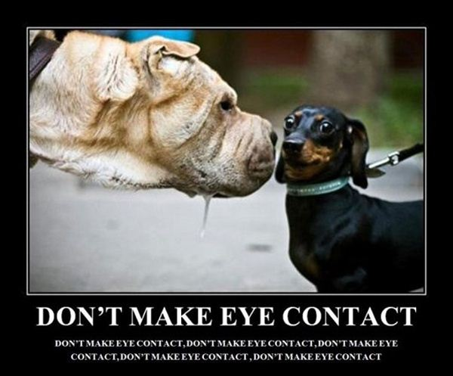

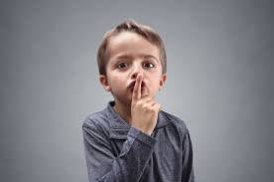



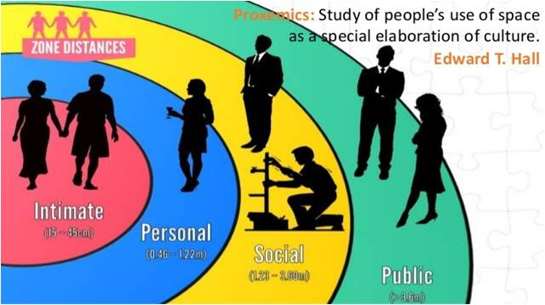

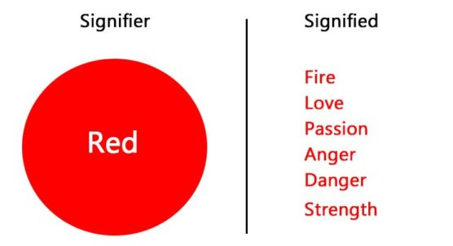

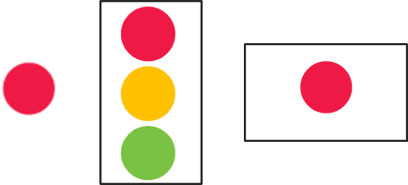

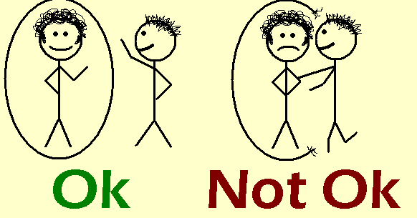

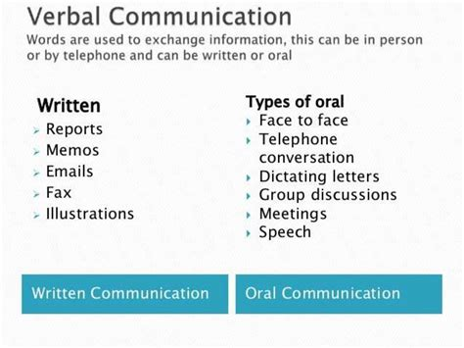

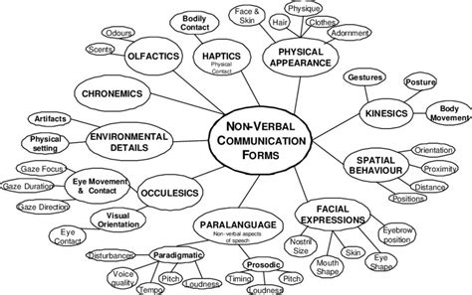

**Two Ways of Communication**

1. Verbal Communication

2. Non-Verbal Communication

**1. Verbal Communication:**

Verbal communication means communication through words. We use words to share our thoughts, feelings and ideas with others.

**Verbal communication can be:**

I. Oral communication

II. Written communication

**Oral Communication:**

Oral or spoken communication comes much before written communication. The simple reason is that man learns to speak long before writing. Speech comes to us very naturally, without making any effort. In the beginning we mimic or copy the sounds we hear. Then, as we grow, we start combining those sounds.

**Advantages of Oral Communication:**

(a) The greatest advantage of oral communication is that it provides immediate feedback and clarification.

(b) Oral communication builds-up a healthy climate in the organization by bringing the superiors and subordinates together.

(c) Oral communication is time saving.

(d) Oral communication is very economical in terms of money and time.

(e) Oral communication is more persuasive than written communication.

(f) Oral communication provides scope to the speaker to correct himself.

**Limitations/Disadvantages of Oral Communication:**

(a) Oral messages cannot be retained or remembered for a long time.

(b) In the absence of written record, oral messages do not have legal validity.

(c) In oral communication it is difficult to assign responsibility.

(d) Oral communication does not always save time. Sometimes the meetings go on and on for a long time.

**Written Communication:**

Written communication comes much after oral communication. It is a result of conscious effort on our part. That is why it is time consuming. Important examples of written communication are letters of various types, memoranda, notices of meetings, agenda, reports and proposals, handbooks, instruction manuals etc.

**Advantages of Written Communication:**

(a) In the first place, written communication provides records for ready reference.

(b) Written communication builds-up legal defences of the organization.

(c) Written communication helps the organization in laying down policies and guidelines.

(d) Good written communication builds-up the image of the organization.

(e) Written communication has the advantage of accuracy and clarity.

(f) Written communication is permanent.

(g) Written communication helps in fixing responsibility.

**Limitations/Disadvantages of Written Communication:**

(a) Written communication, by its very nature, is time-consuming.

(b) In written communication we don’t get immediate feedback as in oral communication.

(c) Sometimes it becomes difficult to get clarification.

(d) Written communication is also costly in terms of time and money.

(e) Written communication is authoritative and dependable.

**II.****Non-Verbal Communication:**

There is a lot more non-verbal communication than verbal. Verbal communication requires conscious effort. But most of non-verbal communication is sponta­neous or without much effort.

**Nonverbal communication broadly comprises the following 7 components:**

i. Kinesics (bodily movements/activity)

ii. Proxemics (space)

iii. Paralanguage (voice) gravy

iv. Haptics (touch)

v. Chronemics (time)

vi. Artifacts (objects)

vii. Physical Appearance

**i. Kinesics:**

Kinesics is the study of body movements. It includes eye contact, facial expressions, gestures, posture, and other bodily actions. Kinesics is popularly referred to as body language.

**ii. Proxemics:**

The term “proxemics” was coined by noted anthropologist Edward T. Hall (1963) and has its root in the Latin term “prox” (as in the word proximity). Proxemics is defined as the study of space and spatial distance. Hall’s research mainly focuses on how individuals use the concept of spatial distance to communicate nonverbally. These space areas vary from culture to culture and from individual to individual. Their contraction or expansion depends on the individual’s culture, gender, personality, social situation, perception, etc.

[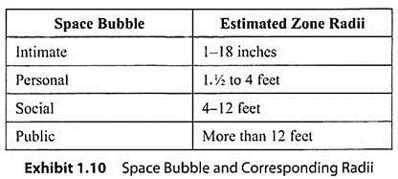](https://www.economicsdiscussion.net/wp-content/uploads/2020/04/clip_image008_thumb2_thumb.jpg)

**Four space areas for any individual**

a. Intimate space

b. Personal space

c. Social space

d. Public space.

**a. Intimate Space:**

Intimate space comprises the area from the body to an outstretched hand/wrist. This space is usually reserved for intimate friends and close family. When the intimate space is violated, one feels threatened. However, when people are forced to surrender their intimate space, they respond by pretending that the trespassers do not exist. For example, when you are squashed in an elevator with other people, you tend to avoid eye contact. There is also a tendency to become rigid and to tense your muscles if someone accidentally brushes against you. These examples illustrate how we deal with intimate-space violation.

**b. Personal Space:**

Personal space is the area reserved for close friends and acquaintances and can also be thought of as a close conversational zone. The seating arrangement in a room, for instance, is often arranged in accordance with an individual’s personal space.

**c. Social Space:**

Social space is the area where an individual feels comfortable interacting with acquaintances and strangers. For instance, in everyday workplace, we interact with each other through our social spaces.

**d. Public Space:**

Public space is the area which is not under our control. Interactions happening in the public space are perceived as anonymous and impersonal. Public speaking, for instance, takes place in the public space bubble.

**iii. Paralanguage:**

Paralanguage refers to the voice effects that accompany speech and can convey emotions, feelings, and attitudes.

**iv. Haptics:**

Haptics is the study of human touch and its implication in communication. Research has emphasized the importance and impact of touch in communication. For instance, a famous quote from the movie Crash says, “It is the sense of touch”.

In any real city, you walk, you know? You brush past people, people bump into you. In L.A., nobody touches you. We are always behind this metal and glass. I think we miss that touch so much, that we crash into each other, just so we can feel something.”

Haptics is not an exact science. It has different connotations in different settings. For instance, friends hugging each other, a mother touching her child’s forehead, acquaintance shaking hands, and a teacher’s hand on the pupil’s shoulder convey different meanings. Therefore, it is important to approach the “touch communication” with caution. To remember, think of the Mimosa pudica (popularly known as “Touch Me Not”). When touched, the compound leaves fold inward or droop. In a similar manner, when we touch someone who does not wish to be touched by us, he/she recoils or retracts from our touch.

**According to Heslin (1974), there are five categories of haptic communication:**

a. Functional/professional

b. Social/polite

c. Friendship/warmth

d. Love/intimacy

**a. Functional/Professional Touch:**

Functional/professional touch refers to touch behavior within an organizational context and the workplace; for example, a physical examination by a physician, a massage by a masseuse, and measurements taken by a tailor. Touch behavior also depends on the power equation between the individuals. It has been observed that superiors are more likely to touch a subordinate, whereas the subordinate is not free to return the gesture.

It is also important to remember that we need to be careful with touch behavior in the professional context. A simple gesture such as the boss’ hand on an employee’s shoulder could mean support and encouragement to one employee, while it could suggest sexual overture to another.

**b. Social/Polite Touch:**

Social/polite touch is touch behavior, which occurs in a social situation; for example, a hug or handshake, a pat on the back, and touching a person’s forearm.

**c. Friendship/Warmth Touch:**

Friendship/warmth touch is usually more common and acceptable for women compared to men in social or friendship settings. According to Anderson (1998), “Too much touch or touch that is too intimate conveys love or sexual interest, whereas too little touch may suggest coldness and unfriendliness and arrest the chance for relational escalation.”

**d. Love/Intimacy Touch:**

Love/intimacy touch is the most important factor in building and maintaining interpersonal relationships. The nature and amount of touching undergoes a change as the relationship progresses from the impersonal to the personal stage. For instance, it has been noticed that men are more likely to initiate touch at the start of a relationship, whereas women are more likely to initiate touch once the relationship solidifies.

**Meanings of Touches:**

**According to Jones and Yarbrough (1985), 18 different meanings of touch exist, which can be broadly categorized into the following seven functions:**

a. Positive affect touches

b. Playful touches

c. Control touches

d. Ritualistic touches

e. Task touches

f. Hybrid touches

g. Accidental touches.

**v. Chronemics:**

Chronemics refers to the study of time and its implication in the communication process. Time is often viewed as a commodity, which can be earned, saved, spent, or wasted. How people use their time can speak volumes about their attitude, character, and culture. For instance, being punctual, meeting deadlines, promptly replying to mails, etc., communicate discipline, sincerity, and reliability.

**vi. Artifacts:**

Artifacts are the material objects used as a form of nonverbal communication to express an individual’s identity. We select artifacts on the basis of (1) how we see ourselves and (2) how we would like others to see us. For example, popular Indian cinema projected spies with long black overcoats, hats, and dark glasses. Senior politicians, for instance, continue to wear khadi kurta-pajamas.

Similarly, we see executives clad in business suits, carrying a briefcase, laptop, BlackBerry phone, etc. This is why globe-trotters often adorn their offices and homes with memorabilia from their travel because these artifacts hold great importance in their lives.

**vii. Physical Appearance:**

Physical appearance refers to the physical characteristics or physical features of an individual. It includes body type (height, weight, muscle tone, etc.); hair type (hair color, hair texture, hair length, hair style, etc.); face (facial features, facial hair, skin tone, skin color, etc.), and so on.